|  |
| --- |
| Findings and Recommendations |
| Telecom Pack Engagement at Sri Lanka Telecom |
|  |
| **IBM Lab Services (ISSW) - Industry Solution & Services** |
| **3/31/2015** |

Table of Contents

1. Introduction 3

2. Findings & Recommendations 3

2.1 Business Process Flows in Blueworks Live (BWL) 3

2.1.1 Findings 3

2.1.2 Recommendations 6

2.2 Telecom Pack Information Model 7

2.2.1 Findings 7

2.2.2 Recommendations 7

2.3 IBM BPM Solution Skills Set 8

2.3.1 Findings 8

2.3.2 Recommendations 8

3. Next Steps 8

# Introduction

IBM SWG Lab Services (ISSW) worked with n*able Business Partner during the period of March 23rd through the 27th to provide assistance with the adoption of the IBM Telecom Pack. IBM provided a Sr. Solution Architect to perform the following tasks:

* Assess the current use of the Telecom Pack
* Walk through the current Order Handling design approach
* Review Existing process flows in Blueworks Live (BWL)
* Ensure process are based on the TMF Frameworkx 12.5 and 13
* Ensure TMF Information Framework is used as the information model and the basis for application integration
* Review recommended best practice approaches for Extending the Business Services and reusing the Telecom Pack Common Messaging Model
* Provide Mentoring and recommendations on the use of IBM Products, including Business Process Manager, IBM Integration Bus, and the Telecom Pack.

# Findings & Recommendations

The IBM Telecom Solution Architect worked with the n*able and I2S technical teams and identified the following areas for improvement:

## 2.1 Business Process Flows in Blueworks Live (BWL)

The Order Handling MACD functions were modeled in IBM Blueworks Live. The MACD functions are named in the Sri Lanka Telecom (SLT) as follows:

* Move =====> Relocate
* Add =======> Create
* Change ====> Modify
* Disconnect => Delete

The Technical team has also identified additional order handling process flows called, Suspend, Resume, and Extended Modifications.

### 2.1.1 Findings

The business process flows defined in IBM Blueworks Live (BWL) were too high-level. Although the level of detail in the process flows might have been sufficient for getting the Sri Lank Telecom managers approval, they don't provide the level of detail required for implementation. The Figure below, from the TM Forum document illustrates how the process hierarchy is implemented by specific types of process at different layers.

It demonstrates that eTOM L0-4 are not sufficient to provide the “detailed process flows” necessary for a deployable artifact. Thus showing the value that the Telecom Pack adds to the TMF process framework.

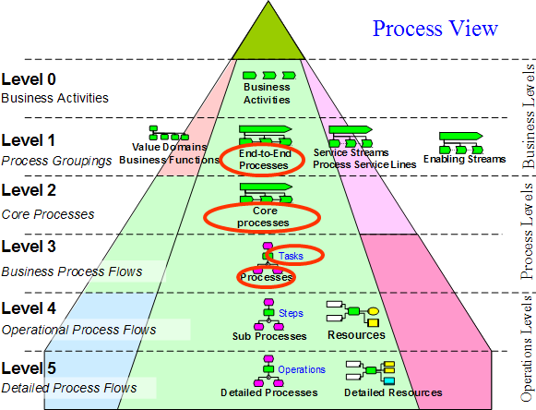

The current Order Handling process flows modeled in Blueworks Live are:

OrderHandling_Cancel, OrderHandling_Create, OrderHandling_Delete, OrderHandling_Modify, OrderHandling_Resume, OrderHandling_Suspend, and OrderHandling_ExtendedModifications

Although they all have different process flow names, at the highest level the activities are the same and are linked together in the same order (see figure 1). At the top level, there is no difference between an OrderHandling_Create and OrderHandling_Suspend.

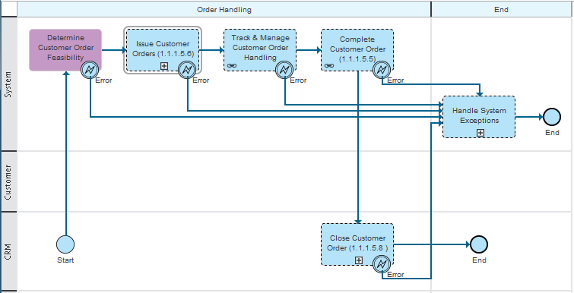

Figure 1 - Order Handling Create Process Flow in BWL

What differentiate one process from the other is the Linked Processes defined in the lower layers. For instance *"Track and Manage Customer Order Handling"* , there are four different Process Layers:

Track & Manage Customer Order Handling Links to

==> Track and Manage Service Provisioning, which links to one of five different Linked Processes (see figure 3)

==> e.g. Track and Manage Service Provisioning(Create/Modify)_V0.7, which then calls a sub process named "Track Service Provisioning Activity", which has an activity named

==> Update Customer Order Business Object

Figure 2 - Track & Manage Customer Order Handling Process Layers

At the third process layer of the Track & Manage Customer Order Handling, the developer needs to select the appropriate linked process when implementing Track and Manage Service Provisioning. They also have to make a decision as to when to implement a "Linked Process" as a process application or a toolkit, depending on its reusability requirements. This seems quite confusing, so a minor mistake might impact other developers using the same Linked Processes. See in figure 3 the linked processes for Track and Manage Service Provisioning.

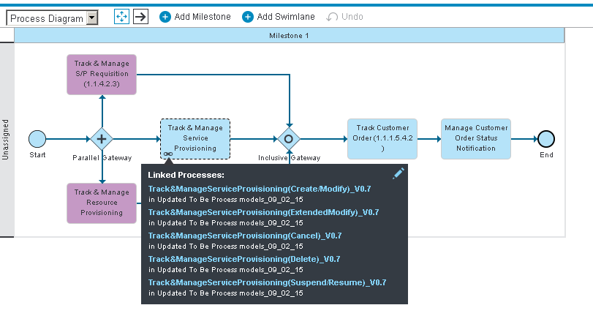

Figure 3 - Track & Manage Service Provisioning in BWL

In addition, the process flows in BWL don't have the proper documentation. Input and output messages are not defined for all activities in the process flows.

### 2.1.2 Recommendations

The way the process flows were modeled in BWL is acceptable for documentation purposes however, a separate process flow for each MACD function needs to be built and customized for implementation purposes. There should be reusable linked process flows and not a list of Linked processes to be selected during implementation.

As mentioned before, the process flows in BWL can be used as documentation, so their implementation can be done directly in Process Designer. In this case, the Order Handing process flows wouldn't be imported/subscribed from Blueworks Live. This might not be the best way to implement Order Handling.

Some activities specified in the process flows should be part of the CRM application instead of the Order Handling process flow. However, after SLT provides a detailed description of the CRM functions, those activities can be removed, if necessary.

Proper documentation of the process flows, including input and output messages will help accelerate development. If possible, also include input and/or output messages of the application APIs. Add as much information to each activity as it's available. This way a Business Analyst can see the process in the context of the operations and a Developer in the context of the process flow and data mapping.

I2s: The BWL live processes we reviewed with Scott from IBM and all the SLT stake holders. All the outcome is based on this discussion. Marilza was never involved in this process and so obviously she might not understand why these decisions were made. For e.g Her comment about BWL processes are good for documentation is a request from SLT to give priority for documentation than implementation in BWL. The implementation specifics are to be taken care in the process designer tool by the implemntation team. Another comment about create and suspend process being the same at high level is also a specific requirement from SLT to differentiate between the process groups to align with their team structure. So the above comments from Marilza are because of her non involvement during the earlier stage of the project. It was Scott from IBM who was involved and all his recommendations were taken.

## 2.2 Telecom Pack Information Model

The Telecom Pack installed with JR51530 iFix provides a hierarchical and simpler to use business objects framework. The latest version of the customer order business object includes Product Offering, which includes Products, and in turn includes Services which includes Resources.

### 2.2.1 Findings

The n*able developers were frustrated with the number of attributes missing in the Telecom Pack Customer Order Business Object (BO). After a detailed analysis, it was determined that the fields expected to be in the Customer Order BO were split between Customer Order, Service Order and Resource Order business objects.

Because an old version of the Telecom Pack was installed, the developers were not aware of the information model implementation in that version. They used only the Customer Order BO and unnecessarily extended it with the missing attributes that were already defined in the Service Order and Resource Order BOs. Further investigation might reveal that other BOs were not used and their attributes were extended in the Customer Order BO. It is possible that this happened due to the technical team's limited knowledge of the Telecom Pack SID Business Objects and their relationships.

### 2.2.2 Recommendations

It's strongly recommended that n*able use the Telecom Pack SID BOs as designed to avoid confusion and future migration issues, even if significant rework of process flows and data mapping might be required.

There is also concerns from the technical team that the SID BOs can potentially get too large when used as designed. However, even when a BO schema looks very large, that does not reflect the size of the XML message. Only populated fields will be included in the XML message that travels through a business process flow. Indeed, this is the whole point of a “canonical” information model, to provide a hierarchical and well defined industry model across the enterprise and is under governance.

The SID hierarchy, a well defined set of object classes and attributes and the relationship between those classes provide a robust and mature Information Model. The adoption of a SID information model stops the technical team from coming up with an arbitrary information model, attribute names such as “CustomerPhoneNumber_CellPhone_Contact” or in the case of the many existing data sets, something like “CustPN_CP_Cont”.

By using a Industry Information Model, in many cases the experience of mapping SID data format to the old APIs data format can be daunting due to lack of the old API's data description. In many cases when performing data mapping requires that every element in the message be described in a data dictionary so that a developer can understand the meaning of the attributes and how they are used, along with an XML message example.

If the decision to change the existing process flows and data mapping is made, this might become a significant change anyway, so it might be a good opportunity to apply iFix JR51530 to the Telecom Pack and use the latest Information Model. iFix JR51530 has been generally available since October 2014.

I2s: As a standard process of using Telco Pack it is common to extend the default data model with the additional fields required for a project, which is done by the technical team in the project as well. The Telco pack mentoring of the team was always the responsibility of the IBM smarter process of competancy and we didn’t receive any recommendation from them to use any specific version and the release of the latest fix pack was also never communicated to the team as well. All the software was downlaoded from IBM passport advantage by SLT & Nable team in Sep 2014 and the same versions are used for all the softwares. Moreover above suggestion is to use new fields instead of extending additional fields, but the functionality can be achieved in either way. There are no functional or techincal gap by using either approach. Nable developers may be frustrated because of their inexperience in working in such complex projects. Moreover the engagigng of Marliza, the telco pack resource is at the wrong timing when the team was already into completion of development.

## 2.3 IBM BPM Solution Skills Set

Sri Lanka Telecom purchased IBM Smarter Process solution, which includes Business Process Manager Advanced Edition (BPM), IBM Integration Bus (IIB), Operational Decision Manager (ODM) and IBM Business Monitor (BAM).

### 2.3.1 Findings

n*able is working with I2S which brings BPM, IIB, ODM, and BAM technical skills to the project. However, the TMF standards and specific Telecom Pack knowledge is missing. The Telecom Pack is the core of the Order Handling design and implementation and needs to be well understood by architects and developers alike.

### 2.3.2 Recommendations

Although IBM has provided some knowledge transfer of the Telecom Pack to n*able and i2S over the last week, it's not enough to design and develop the end-to-end order handling on their own. It's important to have the appropriate Telecom Pack resources working side by side with n*able and i2S for a few weeks providing Telecom Pack depth of knowledge and best practices.

Due to the limited Telecom Pack knowledge, n*able will need assistance in data and operation mappings. Here's the Telecom Pack Knowledge required:

* Understand the TMF SID business objects (and hence the Telco Pack BOs that represent the SID UML), its attributes and how one object relates to another.
* Understand the TAM operations and how they are realized within the Telecom Pack business services.
* Understand the eTOM process flows and how they're used with Telecom Pack.

# 3. Next Steps

To ensure that the Order Handling implementation/deployment goes smoothly, it's recommended to add the following skills to the project:

Telecom Pack Solution Architect: 2 to 3 weeks

* Assist the team with the overall Order Handling design solution, including gathering Order Handling requirements, Use Cases, Test Cases and Business Process Flows in Blueworks Live
* Assist the team with the use of a Product Catalog for Order Handling
* Assist the team with the BPM infrastructure using the Golden Topology
* Identify with the Data Architect and Data Developer standards for process applications and toolkits
* Identify integration endpoints and APIs and map them to the Telecom Pack/TAM operations
* Define and document Business Services and Access Services based on Telecom Pack Interfaces
* Define sequence diagrams for each application integration function
* General SME mentoring on Telecom practices

Telecom Pack Data Architect: 2 to 3 weeks

* Identify the data required by the application touch points and how to map them to the Telecom Pack messages
* Setup a standard process to extend the Telecom Pack with requirements for new fields, new BOs, and new messages
* Map the application specific data format to the Telecom Pack Business Object
* Define how a Product Catalog and business rules can be used to ensure process and business service reusability
* General SME mentoring on object reuse, extensibility and governance.

Telecom Pack Data Developer:

* Develop standards and best practices for message flows, data transformation and access services using Telecom Pack
* Develop standards and best practices for process flows and integration with the Enterprise Service Bus
* Develop standards and best practices for business rules
* General SME mentoring on development best practices and pitfalls.

NOTE: The Telecom Data Architect and Developer could be the same resource.

I2s: These recommendations should have been considered at the beginning of the project during contract stage and should have been implemented along with the project start activity. These suggestions after 8 months of project start will have financial implications. Moreover the existing project team is capable of implementing the current project scope. The current implementation is a SOA project and Telco pack is just one component and the team has used that whereever it is needed and appropriate. For the new processes we have requested enable to consider the recommendation given by Marilza on using the Telco pack .